# PIGS

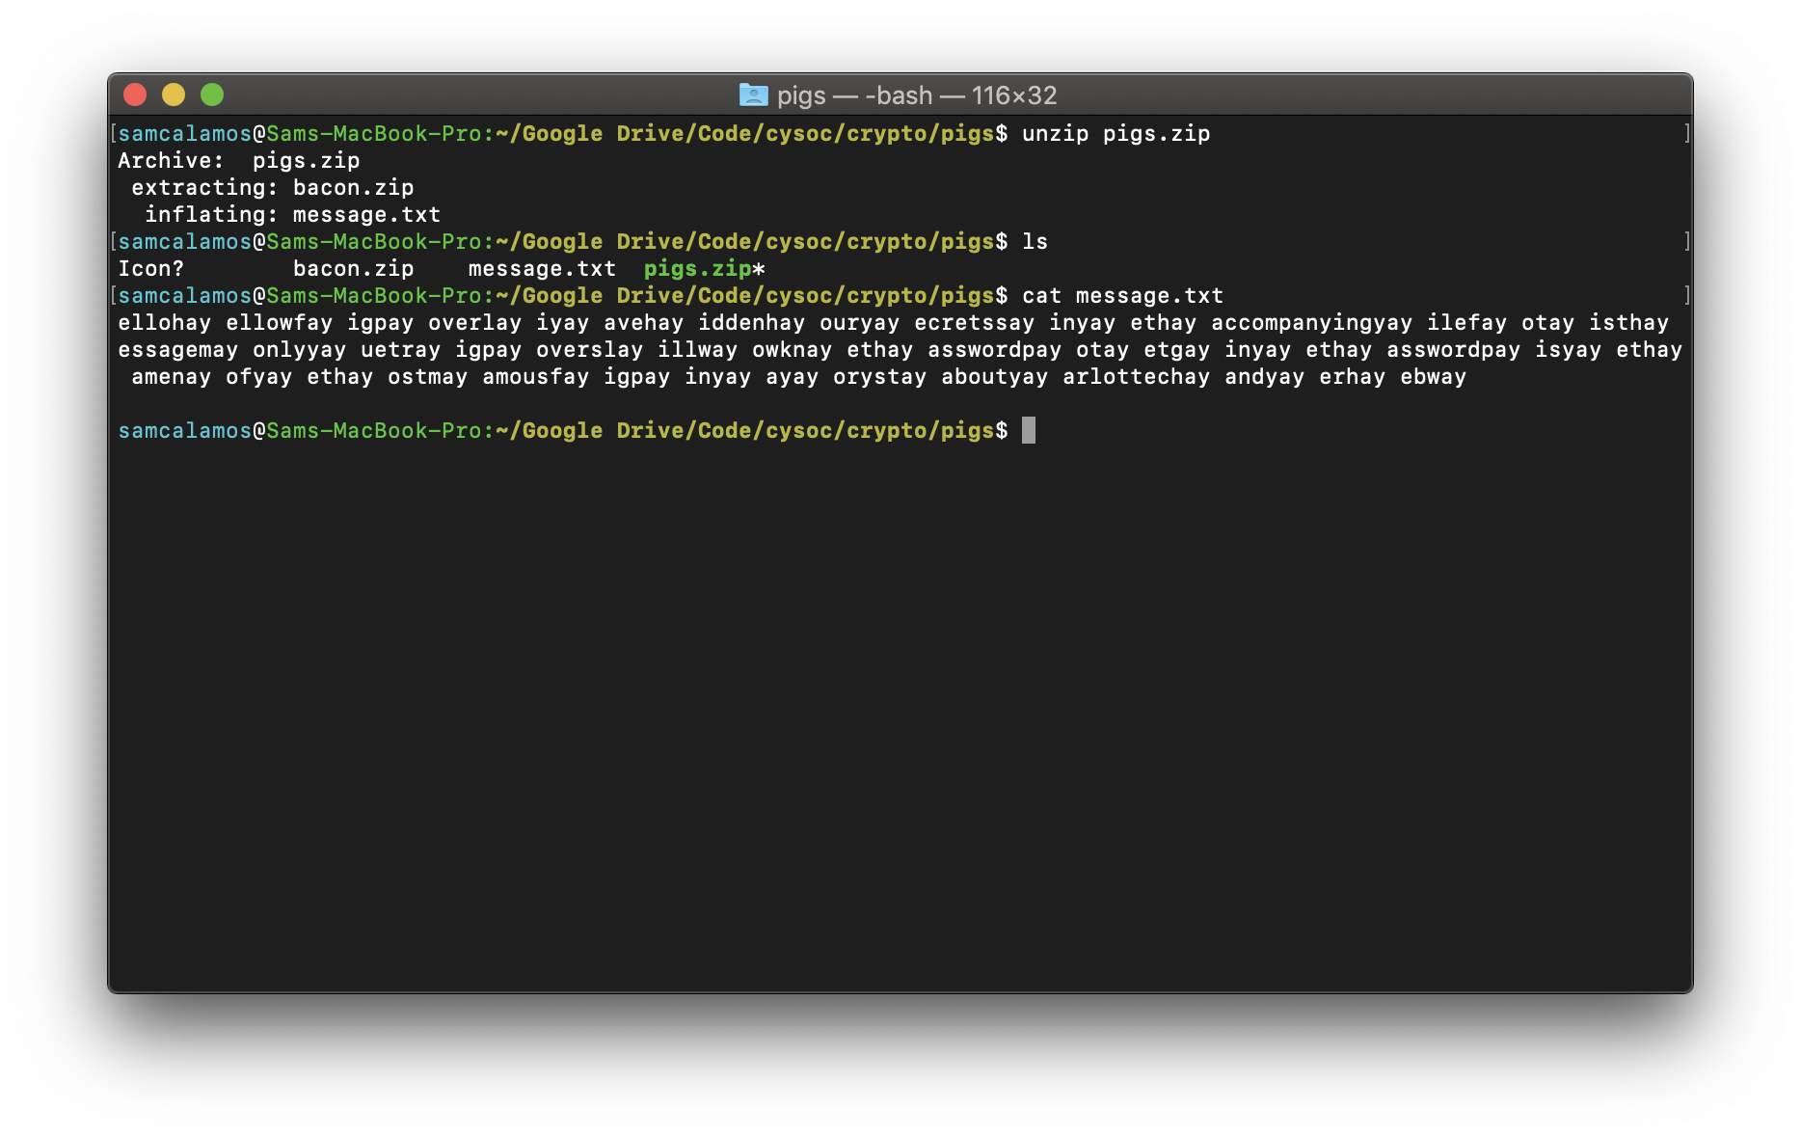This crypto challenge had quite a few elements to it. So we start with a zip file which we unzip to get two files, bacon.zip and message.txt. Trying to unzip bacon.zip we get a prompt for a password which we don’t know.

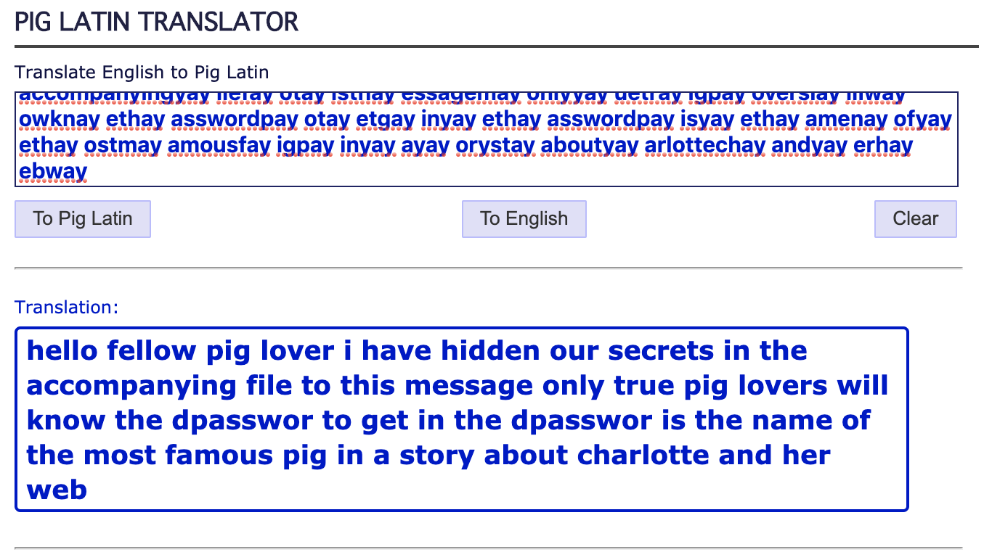We are then given an encoded message written in pig latin! Using an online decoder we can find that the hint is given that the password is the pig in charlottes web.

Googling the name of the pig we find that the name of the pig in question is “Wilbur” so inputting the password “wilbur” (note no caps). Unzip the file and we get encoded.txt. This is encoded in base64 so using a base64 decoder (note on Mac I use the -D option for decode but on kali it is -d).

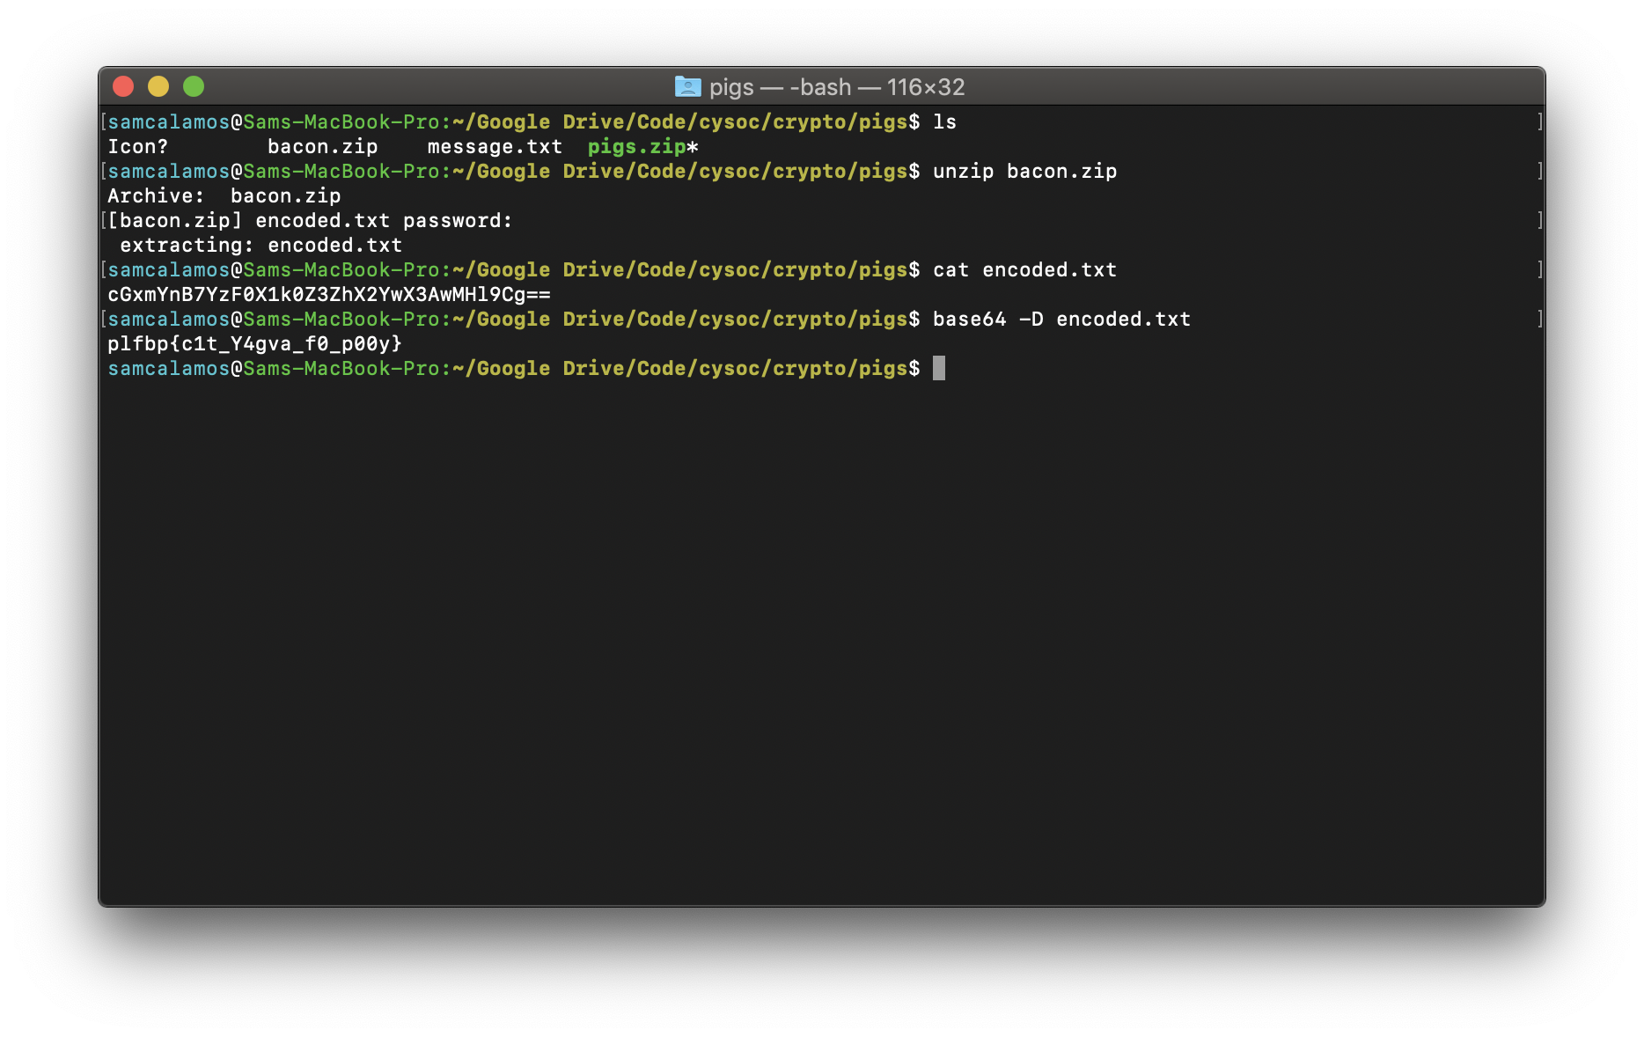

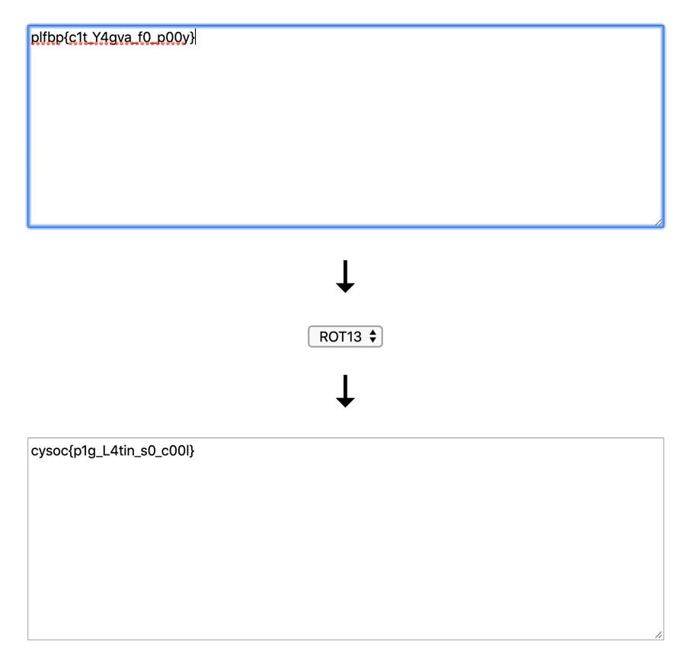Decoding the base64 gives a piece of text that is very close the flag but not perfectly. Which means there is some sort of encryption. In this case it is rot13 or rotate 13 (google it to find out more about how it works). Anyway using an online decrypter we get the flag.

Which gives the flag:  
**cysoc{p1g_L4tin_s0_c00l}**